Tasking Manager Org Profiles to Field Mapping Tasking Manager
Object Sequence Diagram
The two end points represented in this scenario can be any two projects utilizing the TM-Admin framwork.
@startuml
Participant “Tasking Manager” as TM
Participant “Field Mapping Tasking Manager” as FTM
TM -> FTM: ShareOrgProfile(name, supported_org_attributes)
activate FTM
alt “org exists”
FTM -> FTM: Update user information
note right: tbd how to\nmatch orgs
else “org does not exist”
FTM -> FTM: Create new user
end
alt “Success”
TM <- FTM: SUCCESS
else “Failure”
TM <- FTM: FAILURE, Error Code, Error Msg
deactivate FTM
end
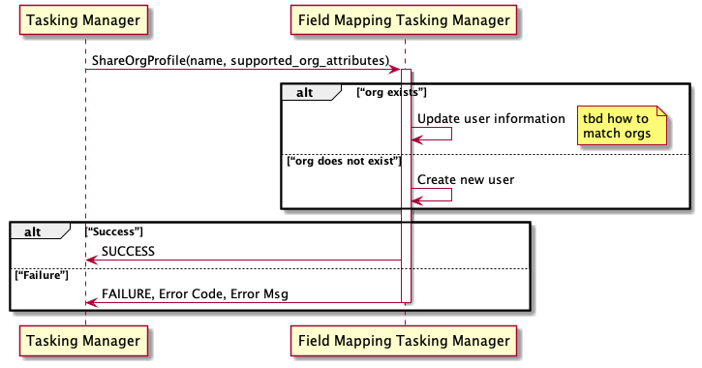
@enduml

